Coopers Lane
Primary School

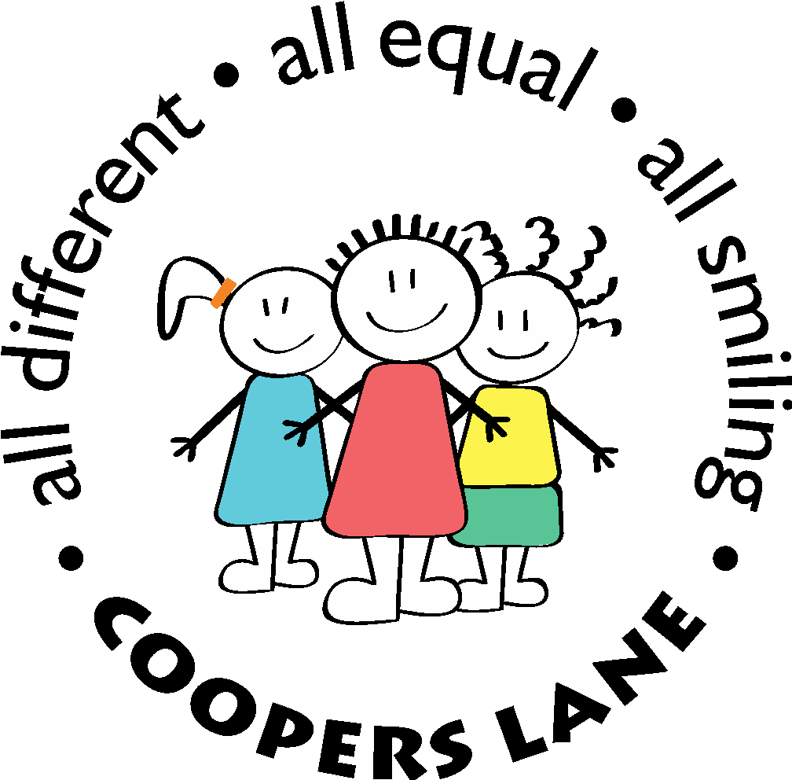

Behaviour Policy

Author/ Checked: | Paul Hooper | Date: May 2023
Approved by: | Governing Board | Date: 23rd May 2023
Issue date: | May 2023 | Next Review due by: May 2024

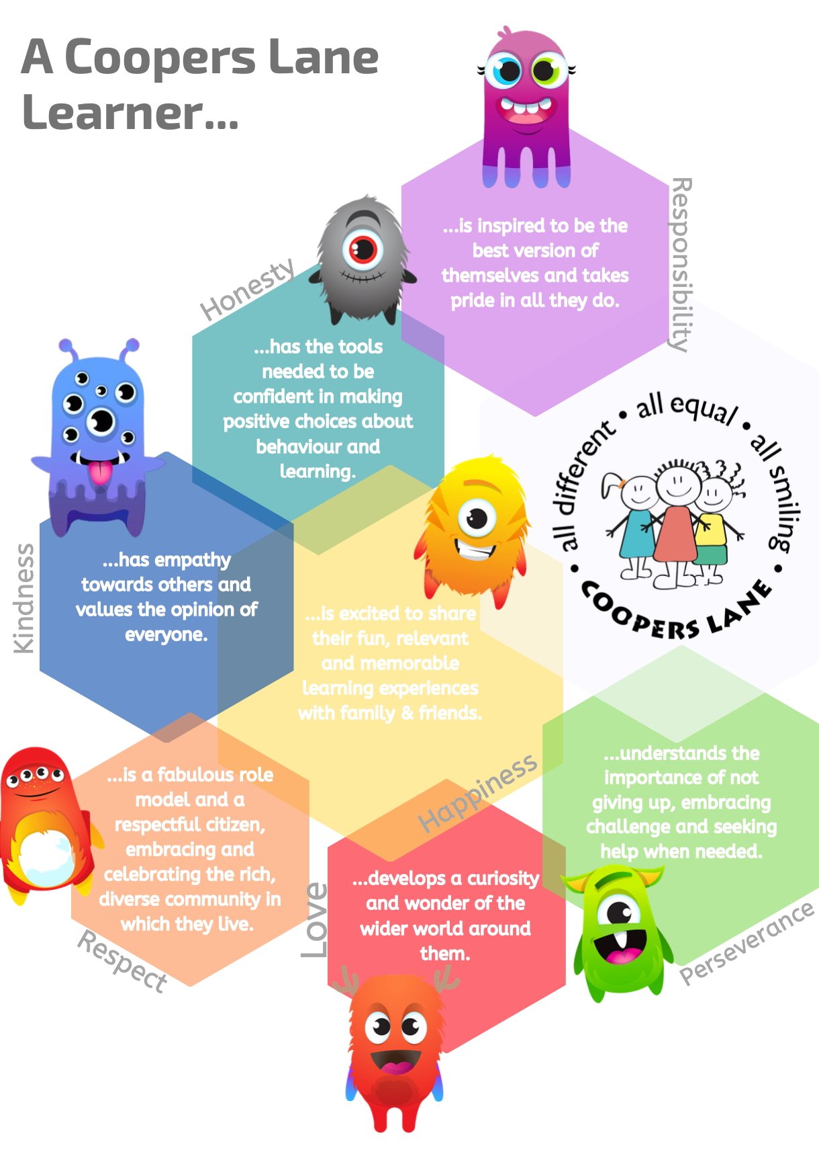
Behaviour Policy – Coopers Lane School
The following policy has been guided by and makes reference to the latest guidance from the DfE and other relevant bodies and takes cognisance especially of:

- Behaviour and discipline in schools, Advice for head teachers and school staff (January 2016)

- Keeping children safe in education, statutory guidance for schools and colleges (September 2021)

- Equality Act 2010

- Behaviour & Discipline in schools – links to further guidance (September 2020)

- Use of reasonable force - advice for head teachers staff and governing bodies (July 2013)

- Statutory Guidance – School Suspensions and Permanent Exclusions (September 2021)

- Education Act 2011

- SEND Code of Practice (April 2020)

Rationale
This behaviour policy has been written following consultation with all members of the school community – staff, parents/carers, and children. At the core of this policy is the belief that everyone at Coopers Lane is valued and respected. We want all members of our community to enjoy relationships based on mutual respect, co-operation and safety.
Aims
As a school, we believe in the promotion of positive behaviour for learning, and our aims are:
- To provide children and adults with a caring, stimulating and safe environment in which they can learn and work
- To promote clear and consistent expectations and high standards for behaviour and learning
- To value all members of our school community
- To work with all parents/carers to support children’s learning and development
- To develop an ethos of mutual respect throughout the school
- To provide an environment where the diversity of social and cultural backgrounds within the school are valued, respected and celebrated
- To listen to and respect the views of both children and adults within the school community
- To ensure that rules, sanctions and rewards are applied justly and fairly
Values
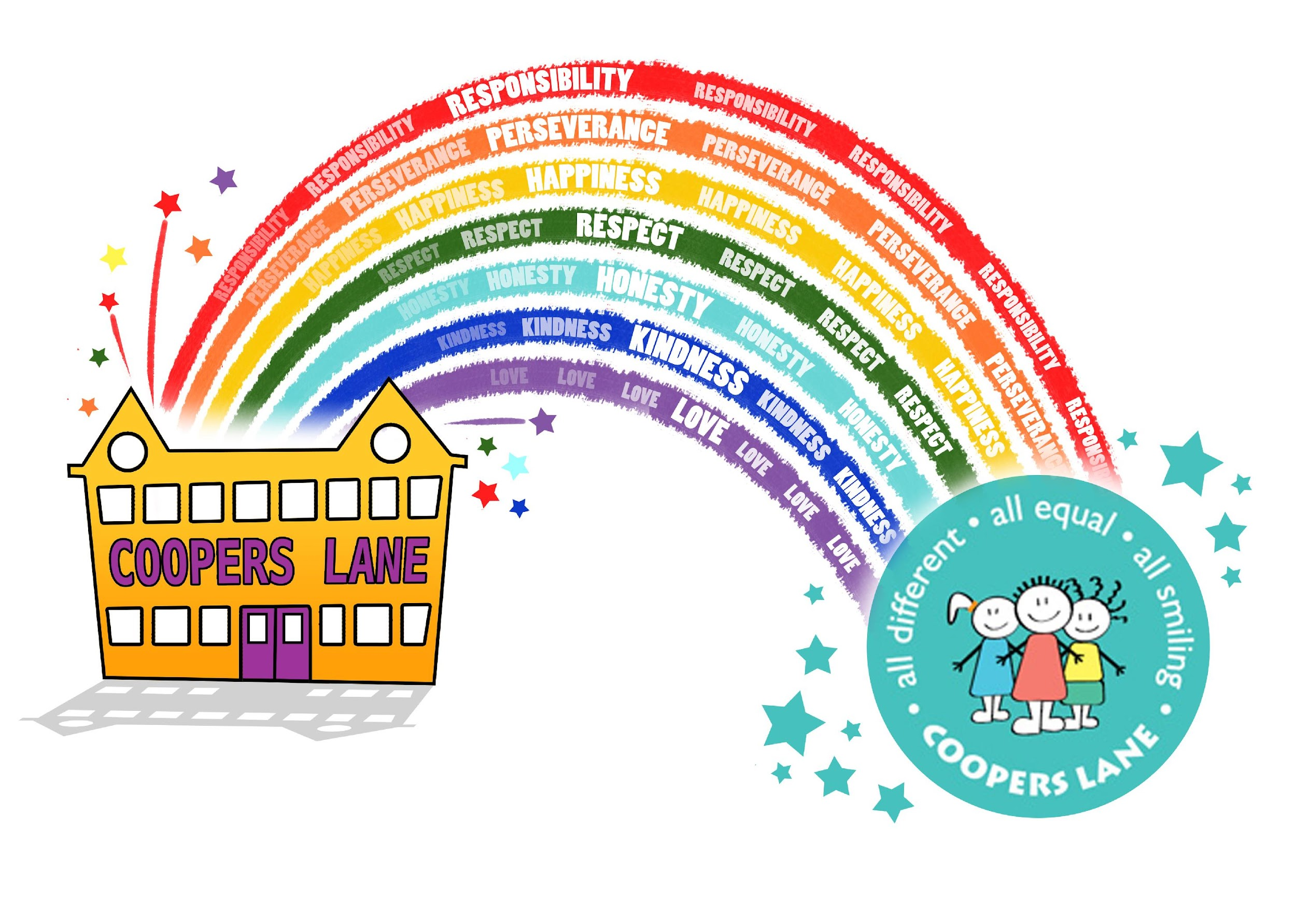
Our values are central to all that we do and should be reflected across the school. Our school values are as follows:
- Perseverance
- Honesty
- Kindness
- Happiness
- Love
- Responsibility
- Respect

Our values are displayed in every classroom and in other communal areas around school. They are regularly discussed with pupils both in class and during assemblies.
Teaching the values throughout the curriculum ensures that all children understand and know how to be a “Coopers Lane Learner.”

“If we don’t stand up for children…
then we don’t stand for much.”
Marian W. Edelman

UNICEF Rights Respecting School
We are a GOLD ‘Rights Respecting’ School.
The Rights Respecting Schools Award (RRSA) recognises achievement in putting the United Nations Convention on the Rights of the Child (CRC) at the heart of a school’s planning, policies, practice and ethos.
A rights-respecting school not only teaches about children’s rights but also models rights and respect in all its relationships: between teachers/adults and pupils, between adults and between pupils. These are also the principles of ‘Restorative Approaches’ (to enable the building, maintaining and repairing of relationships), which we practise at all levels within our school community.
Pupils have a right to be heard, a right to learn, and a right to be safe. Teachers and staff have a right to teach in a friendly, safe and supportive school. Parents and carers have a right to feel welcome and be heard, and to know that their children learn and achieve in a friendly, safe and supportive school.

Pivotal
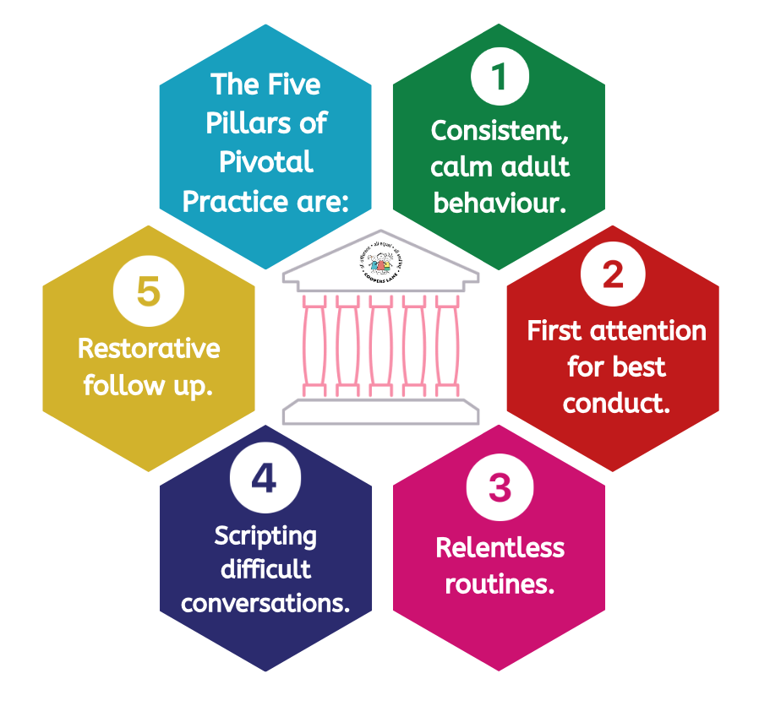
The strategies and approaches we use in cultivating high standards of behaviour, including learning behaviour, at Coopers Lane are largely based on those of the ‘Pivotal Approach’ to behaviour management. This approach focuses on building strong relationships, restorative practice, use of clear and consistent steps/systems and the importance of consistency in adult behaviour when supporting children.

The following rules, responsibilities and routines are all built upon these pillars and promote positive behaviour at all times.
Rules - Ready, Respectful, Safe
The school has three simple rules, which are aimed at ensuring we can all work together in a supportive atmosphere, with the common purpose of helping everyone to learn and to be happy. The rules apply to all members of the school community, at all times. These rule are:
Ready
- We are ready to learn
- We arrive at school on time
- We have the correct uniform and PE kit
- We have our equipment ready
- We are ready to listen and try our best.

Respectful
- We listen when others speak
- We look after property belonging to the school and other people
- We respect that other people have different ideas, beliefs and backgrounds to our own
- We respect that people may look different and have different needs but we all feel the same emotions.
- We respect the rules of the school and the laws of society.

Safe
- We travel to and from school safely
- We move around school in a safe manner
- We follow instructions to keep ourselves safe
- We use equipment safely
- We stay safe online and make safe choices in our community.

Responsibilities
We expect our community to demonstrate our school values at all times.
Children Will
- Perseverance: Always try to complete work to the best of their abilities, even when challenged.
- Kindness: Be kind and helpful to other children and adults.
- Honesty: Tell the truth and be confident to admit when mistakes are made.
- Love: Take care of themselves and each other.
- Happiness: Have a positive attitude towards school. Be a good friend to other children.
- Responsibility: Ask adults for help when there is a problem. Look after their own and others’ belongings. Always take responsibility for their actions.
- Respect: Listen to others carefully without interrupting. Follow our school motto by accepting that we are ‘all different, all equal, all smiling’.
Staff Will
- Perseverance: Provide appropriate challenge for all children and encourage them to complete work to the best of their abilities, even when challenged. Celebrate all achievements along the learning journey.
- Kindness: Be kind and helpful to all children and adults. Be sensitive to the needs and feelings of others.
- Honesty: Tell the truth and be confident to admit when mistakes are made. Show understanding to others when they make mistakes.
- Love: Provide a safe and secure learning environment. Build positive relationships with parents, carers and the community. Value children and their relationships. Have a love of learning and teaching.
- Happiness: Have a positive attitude towards the whole school community. Reinforce the School Values by rewarding positive behaviour. Greet the children with a smile.
- Responsibility: Demonstrate the school values at all times and be a positive role model to the children. Provide a safe, inspiring learning environment in which all children can reach their potential.
- Respect: Treat all members of our school community equally. Listen and communicate sensitively to children and adults. Follow our school motto by accepting that we are ‘all different, all equal, all smiling’.
Parents/Carers Will
- Perseverance: Support children at home with their learning and be patient as they develop their understanding.
- Kindness: Be kind and helpful to all children and adults. Be sensitive to the needs and feelings of others.
- Honesty: Tell the truth and be confident to admit when mistakes are made. Show understanding to others when they make mistakes.
- Love: Provide a safe and secure home environment. Build positive relationships with the school community. Encourage a love of learning.
- Happiness: Have a positive attitude towards the whole school community. Reinforce the School Values by rewarding positive behaviour. Show an interest in children’s learning.
- Responsibility: Demonstrate the school values at all times and be a positive role model to the children. Make sure the children are at school on time every day and ready for learning. Communicate regularly with the class teacher.
- Respect: Treat all members of our school community equally. Listen and communicate sensitively to children and adults. Follow our school motto by accepting that we are ‘all different, all equal, all smiling’.
Rewards
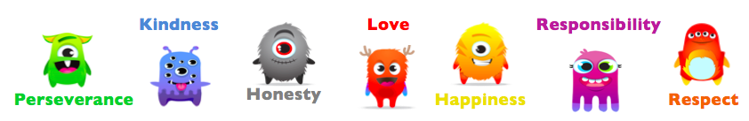
Our values apply to the whole school community and all members of staff will use these values to reward and sanction the children. We use ‘Dojo Points’ across the school as our reward system and the points are awarded for demonstrating the school values.

- A ‘dojo point’ will be awarded when a child clearly demonstrates one of the values.
- The class is rewarded with a ‘Dojo Dollar’ every time they make it to a multiple of 10 points in a given week.
- Once awarded, Dojo Dollars are stored in a class jar and are used to buy whole class rewards from a shopping list.
- The class totals are cleared at the end of each week.
- Midday Meals staff will give out dojo dollars at lunch times.
- Two children from each class will be given certificates in assembly each week on a Friday, one ‘VIP (Values in Practice) Award’ for demonstrating the values and one for showing a growth mindset. The chosen children will then be able to place their picture on display in the hall for that week.

The system will be consistent across the school and we encourage parents and carers to promote these values at home so that the children are fully aware of how to show them on a daily basis.

It is essential that all children receive positive encouragement and praise and build positive relationships with adults in school. Alongside the above, we achieve this by:

- Giving non-verbal praise such as a smile or positive body language.
- Providing verbal praise (genuine, specific and for all children).
“You don’t have to be better than everybody else. You should strive to be better than you ever thought you could be.”
Anon
- Remembering important personal information about children.
- Going out of our way to give special mentions to parents/carers at the end of the day.
- Choosing children as monitors for certain jobs.
- Sharing work on the school website and class dojo portfolios in Early Years.
- Giving stickers.
- Presenting certificates for good attendance.
- Recognising achievements outside school e.g. sport etc.
Sanctions
We recognise that we do not always know what experiences a child has had prior to coming to school or during different parts of the school day. Therefore, it is extremely important that we are welcoming and positive and that the children feel that all staff are firm, fair and genuinely like them.
When poor behaviour occurs, sanctions will be applied fairly and consistently and will be appropriate to the behaviour in terms of severity and duration. We use sanctions to help children learn that their actions have consequences and to deter further poor behaviour. These sanctions are based around restorative approaches.
A restorative approach involves helping people to resolve conflict by sharing how they feel, listening, empathising with others and agreeing on what needs to be done to make things right. When pupils truly understand the consequences of their behaviour towards other children or adults, it helps them to make more sensible choices in the future.
Initially, it is the responsibility of the class teacher to apply fair, clear and consistent sanctions in the classroom. Staff will use this cycle to deal with undesirable behaviour:

Reminder

Caution

Last Chance

Time Out

Reparation

Stage | Action/Aim | Possible Script
Reminder | Remind the child of the expectation and solve any problem quickly so the child can succeed independently. | “Do you remember what you’re supposed to be doing? Can you tell me what you should be doing now?”
Caution | A clear verbal caution delivered privately and calmly that makes the learner aware of their behaviour and which value they are not showing. State the behaviour that is required. | “I’ve noticed you are not following our rule of being... I need you to...I know you can do this; be the best you can be. Thank you for...”
Last Chance | Continue speaking to the learner privately, calmly with a gentle approach, side-on at eye level or lower – non-threatening. Give them a final reminder to engage and do the right thing in class. State the behaviour you need to see and clearly outline the consequences if they continue. | “You have been spoken to already  in this session, I need you to ... if you don’t... you will be sent to another class (or must finish it at playtime). This is your final reminder in class. You can do this!”
Time Out | At this point, the learner will have time out in a designated class (within the phase), unless an individual behaviour plan specifies something different. Once in the receiving class, the child should work quietly and independently and, when the child is ready to return, they may go back to their own class.  Now move to reparation. | “I’ve already given you your final reminder, I now need you to go...Please take your book/work with you.”
Reparation | At the next possible break/lunchtime, or as soon as possible afterwards a restorative conversation MUST take place with the class teacher and child or the two children concerned, using the restorative questions. (SLT can support where required). | The aim is to repair and rebuild relationships using a range of restorative questions e.g:  Restorative Questions  - - What happened?  - - What were you thinking/feeling at the time?  - - Who has been affected and in what way? - What could you have done differently?  - - What do you think needs to happen to make things right?

A member of the pastoral team/SLT may be called if:
- The learner refuses to engage with the above process.
- The behaviour is a serious breach of the school values e.g. violence/dangerous behaviour/discriminatory language or behaviour
Once the child is ready to discuss the incident, it is vital that the member of staff who first dealt with the incident carries out the reparatory conversation. A member of the Pastoral or Senior Leadership team should provide support/cover to facilitate this.
Lunch Time
If children are disrespectful to any adult during playtime or lunchtime, the above steps will be followed and the time out will take place with the staff member involved. If they do not take responsibility for their actions, a member of the pastoral team/SLT may be called for. This may result in some time out from the playground.
A member of the pastoral team/SLT may be called if:
- The learner refuses to engage with the above process.
- The behaviour is a serious breach of the school values e.g. violence/dangerous behaviour/discriminatory language or behaviour
Reasonable Force
At Coopers Lane School, we are committed to encouraging our pupils to make positive behaviour choices. We aim to avoid the need for physical intervention and regard this as necessary in only very few situations. However, on rare occasions, persistent negative behaviour may result in a situation that requires some form of physical intervention from adults in order to keep everyone safe. Reasonable force may be needed to prevent pupils from disrupting good order and discipline, injuring themselves or others or damaging property. In this situation, the following principles will be followed:
- physical intervention should be used as a last resort when all other strategies have failed
- all physical contact will be kept to a minimum
- physical intervention will be used in ways that maintain the safety and dignity of all
- a member of the Senior Leadership Team will be called to any situation where physical intervention has been deemed necessary
- all incidents will be reported to the Headteacher
- the Headteacher or a member of the Senior Leadership Team will be responsible for discussing what has happened with all parties involved, and all details of the situation will be recorded
- parents will be invited in to school to discuss the situation.
If the behaviour is part of an ongoing pattern, it may be necessary to agree/update a behaviour plan and risk assessment. In some cases, additional support from outside agencies may be deemed necessary.
Section 93 of the Education and Inspections Act 2006 allows teachers and other persons who are authorised by the Headteacher who have control or charge of pupils to use such force as is reasonable in all the circumstances to prevent a pupil from doing, or continuing to do, any of the following:
- causing injury to his/herself or others
- committing an offence
- damaging property
- prejudicing the maintenance of good order and discipline
Please see the web link below for the Department for Education Advice (July 2013) for further clarification on the use of physical intervention: https://www.gov.uk/government/publications/use-of-reasonable-force-in-schools
Reporting Incidents
The class teacher will communicate all concerns regarding behaviour to parents/carers. In more serious cases, the Year Group Leader or a member of the Senior Leadership Team may be involved.
A record of all serious behaviour incidents will be recorded on Scholar Pack by the adult dealing with the incident (usually class teacher, learning mentor or member of SLT).
Individual Behavioural Plans – Appendix A
For children whose behaviour is persistently disruptive, an alternative, individual behaviour plan will be used. This will be discussed with parents/carers.
Any child not adhering to their individual behaviour plan, or any child putting themselves and others at risk, will be at risk of exclusion from school.
Exclusions
At Coopers Lane, prevention rather than punishment is always our starting point, and through the use of robust systems for managing behaviour, we ensure that our pupils are very seldom excluded. However, very serious incidents including violence or verbal abuse, behaviour that threatens the health and safety of others or damage to property are likely to result in a fixed term exclusion. Only the Head Teacher can exclude a pupil. In this situation, the following guidelines will be adhered to:
- the exclusion of children on a temporary fixed term basis or during lunchtimes will be reported to the LA using the agreed format (kept in the school office) and parents will be informed using the agreed letter (kept in the school office).
- if a child is subject to an exclusion, the class teacher will be responsible for setting appropriate work for that pupil to be completed during the period of a fixed exclusion. This work will be marked when the child returns to school.
- the parents of the child and the pupil will be expected to attend a back to school meeting with the Head Teacher on their return to school to ensure that the child understands that poor behaviour will not be tolerated. This meeting will be considered a fresh start, enabling mutual trust and respect to be restored.
Please see the web link below for the Department for Education Advice (September 2021) for further clarification on exclusion from school: https://www.gov.uk/government/publications/school-exclusion

Appendix A – Individual Behaviour Plan
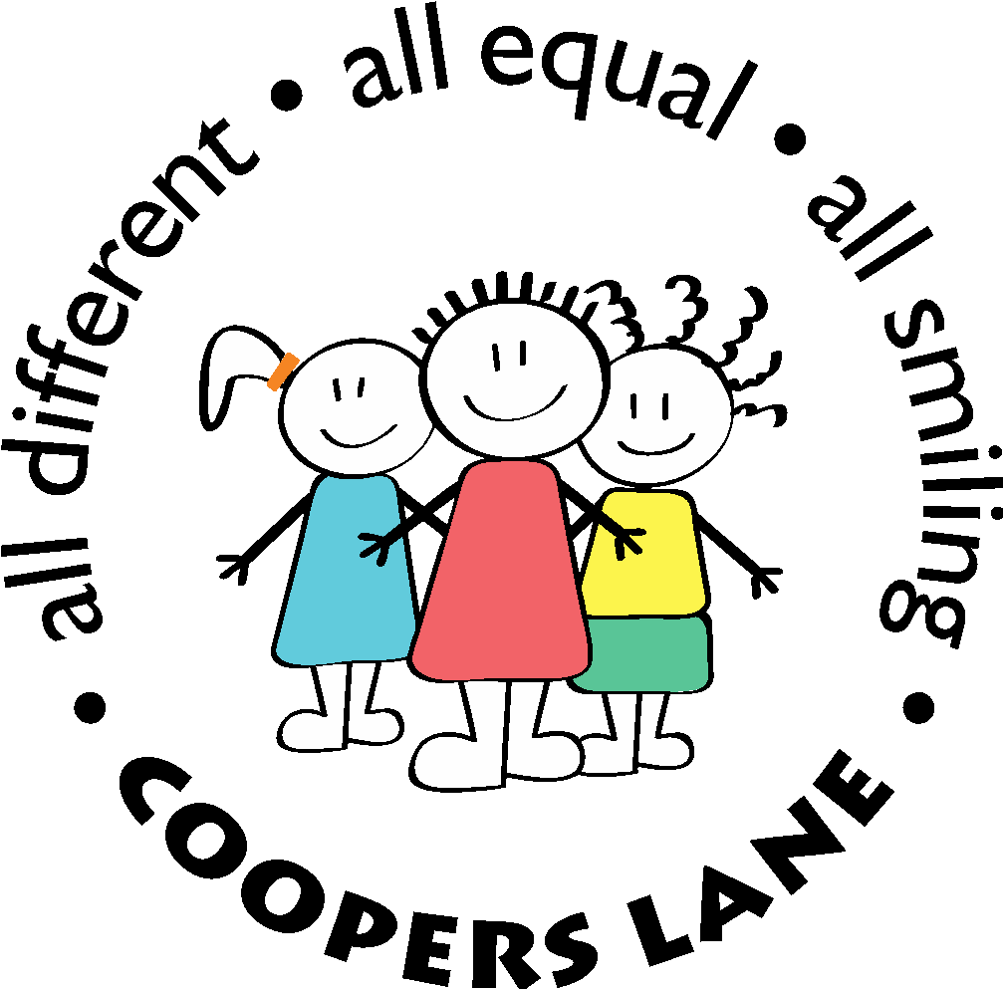
Individual Behaviour Plan
PUPIL NAME: CLASS: YEAR GROUP:
Date of birth:  Date plan starts: | Medical conditions/needs:  Staff working with the pupil:
Skills and Talents  Transitions well in the morning  Use of calm space | Achievements
Likes  - Gaming  - Drawing  - Making puppets  - Colouring  - Helping Adults | Dislikes  - Loud noises  - Maths  - Changes in routine  - Being in unfamiliar environments
Challenging behaviour  What does it look like?  - Shouting  - Hitting  - Name calling  What triggers it?  What are the risks?  - Hurting himself  - self harm  - punching  - scratching  - Damaging property  - breaking glasses  - ripping books  - Hurting others  - hitting out  - kicking objects | Targets  What are we working towards?  - Self confidence  - Expressing feelings  - Stopping impulsivity (writing)  - Stay on track with learning  - Following instructions well  How do we get there?
Strategies for positive behaviour  How do we maintain positive behaviour?  - Phrases to use  - Rewards, motivators | Early warning signs  How do we prevent an incident?  - What to look out for  - How to respond (reminders, alternative environment)
Reactive strategies  How do we diffuse the situation?  - What to do and what not to do  - Phrases to use  - Calming techniques  At what stage should another member of staff be informed? Who should this be? | Support after an incident  How do we help the pupil reflect and learn from the incident?  Is there anything that staff can learn about working with this pupil?
Log of incidents: All behaviour incidents logged on Scholarpack
IBP evaluation and next steps:
How effective is the plan?
Record suggestions to be considered when this plan is reviewed.

Date of next review:
Agreement:  Parent name  Parent signature  Date | Staff name  Staff signature  Date

