Week | Date given | Autumn 2  Homework Task | Due date
1 | 5.11.20 | This week we would like you to draw a timeline/story map of the key events in your story. Try to think imaginatively about the way you present your work.  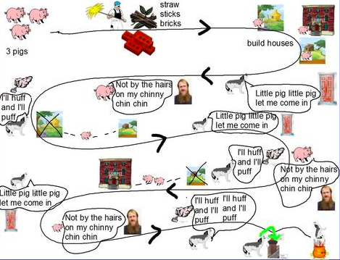  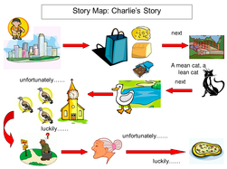  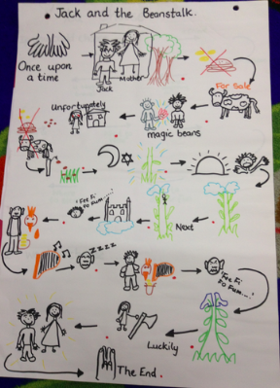 | 2.11..20
2 | 12.11.20 | This week we would like you to complete a page from a holiday brochure based on the setting of your book. You will need to include information on: location, climate, amenities, places to stay, places of interest, perhaps a map and anything else you feel is appropriate. Remember that holiday brochures are designed to persuade people to visit. | 9.11.20
3 | 19.11..20 | This week, we would like you to take the main events of the story in your reading book and turn it into a comic strip with pictures, captions, speech and thoughts bubbles. Remember that it should show us how well you understand the main events and characters within your book. Don’t forget to include the book title and author in the heading and that it  should reflect 40 minutes of your best effort. | 16.11.20
Week | Date given | Homework Task | Due date
4 | 26.11.20 | This week we would like you to write a poem based on your book. Remember that it should show us how well you understand what you are reading. Include the book title and author in the heading.  Think about how you might present your poem and remember that your work should reflect at least 40 minutes of your very best effort. | 23.11.20
5 | 3.12.20 | This week we would like you to recommend a book for Christmas for the following people and explain your choices, using a short paragraph for each person and why the book you have chosen matches them.  They are:  - Amy. Age 12. Likes dancing and is into fashion. Her favourite colour is pink and she loves anything sparkly but is actually a bit of a ‘Tomboy’. Her favourite subject at school is PE.  - Jamil. Age 10. He’s an excellent reader and plays the drums. He has loads of friends, enjoys art and loves to make models in his spare time.  - Mary. Age 11. She’s a canoe water polo player. She doesn’t have much time to read but really enjoys David Walliams books…but she fancies a change. She’s also a bit of a tomboy and enjoys camping.  - Derek. Age 9. Thoughtful and kind boy who is popular with his peers, Derek most enjoys playing computer games but knows that he should try and read more. | 30.11.20
6 | 10.12.20 | Please write a letter from a character in your book to Father Christmas. What would they wish for to make their dreams come true?  (Father Christmas doesn’t always have to give materialistic wishes to make dreams come true.)  Please make sure that you explain why your character has these wishes so that we know that you understand the story you are reading. | 7.12.20
Week | Date given | Homework Task | Due date
7 | 17.12.20 | Looking at language.  This week we would like you to look at the language the author of your book has chosen to use. Find 10 words or phrases that appeal to you and explain why they are effective. Your teacher will show you how to approach this task in class. Please make sure that you include the title and author of your book in this work. | 14.12.20

