Week | Date given | Autumn 1  Homework Task | Due date
1 | 10.9.20 | For your first entry in your reading journal, we would like you to tell us about your experience reading so far. Writing neatly and in full sentences, you need to include the following information:  - What genre of books do you enjoy reading?  - Who are your favourite authors?  - What are your favourite books?  - How often do you read?  - Do you prefer reading with someone or on your own?  - Do you enjoy reading? Why?  - Are there any books you want to read? | 14.9.20
2 | 17.9.20 | Your task this week is to create a relationship web for a main character in your book. You should include details about how the characters get along with one another and how they are linked.  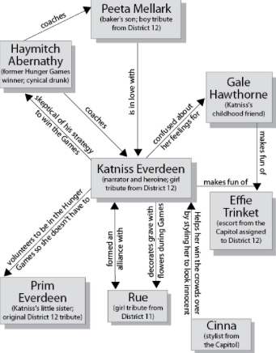  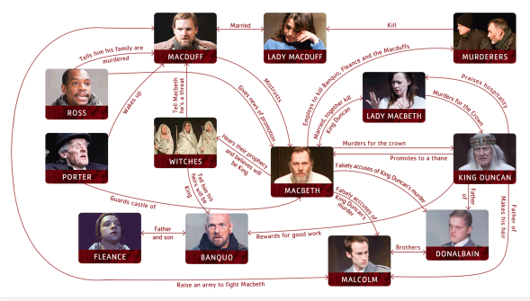 | 21.9.20
Week | Date given | Homework Task | Due date
3 | 24.9.20 | Book covers are changed and updated regularly. This week please redesign the cover and rewrite the blurb for your book. | 28.9.20
4 | 1.10.20 | This week we would like you to write a detailed character description of one of the characters from your book. (If you are currently reading a non-fiction book, choose a character from your last fiction book). This a chance for you to show us how you can use the fantastic words, phrases and sentence openers from our work in Literacy, in your own writing. Think carefully about how you can develop your own ideas logically in your paragraphs and ensure that your writing flows.  Remember that it should show us how well you understand the characters within your book. Don’t forget to include the book title and author in the heading. | 5.10.20
5 | 8.10.20 | This week we’d like you to write a persuasive report for why someone should read your book. You may like to include:  - The main messages and themes of the book.  - How it has been written to entertain the reader.  - The ways that reading it could change your life for the better. | 12.10.20
Half term | 15.10.20 | This week, please write a letter from one character in your book to another character in your book. Then respond to it. Please remember that we do not want the whole story. Instead pick an incident, key events or feelings to base your letters on.  For example  Goodnight Mr Tom by Michelle Magorian  Dear Mr Oakley,  I hear that you have been looking after my son (Willie Beech) whilst London endures some seriously damaging bombing. I wanted you to know that he can be an evil, sinful boy and I hope that you’re using the leather belt I sent you to keep him under control.  I am a very poor woman and will not be able to send Willie any letters, nor will I visit. Please ensure that he says his prayers every night and that he’s scrubbed clean for church on Sunday’s.  Yours faithfully,  Ms Beech  Dear Mrs Beech,  Thank you for your letter. William was pleased to hear your were asking after him and I have told him that you send him your love and best wishes. I have put the belt somewhere safe until I need to use it. Your boy is a scrappy young thing but the country air is doing him good. He’s eating better now and growing tall and strong. We live right next to the church so there’s no need to worry. Every night, I read bible stories and, like the rest of the village; we do attend church every Sunday.  It is a shame you cannot visit for William’s birthday but we have all made him cards and presents to make up for your absence. If you wish, we could send you some eggs and butter to help you during rationing?  Your humble servant,  Thomas Oakley | 26.10.20

